SNR of male & female voice using SSB Modulation

Sumit Kumar Patra *Electronics and Communication Engg.   
Faculty of Engineering and Technology  
SOA(deemed to be University)*Bhubaneswar, Indiasumitpatra30656@gmail.com

_Ishita Mohanty *Electronics and Communication Engg.   
Faculty of Engineering and Technology  
SOA(deemed to be University)*Bhubaneswar, Indiaishitamohanty1954@gmail.com

_Laxmipriya Moharana  
*Electronics and Communication Engg.   
Faculty of Engineering and Technology  
SOA(deemed to be University)*Bhubaneswar, Indialaxmipriya.moharana@gmail.com

*Abstract*— Speech quality in communication systems is heavily influenced by Signal-to-Noise Ratio (SNR), which varies based on voice characteristics. Male and female voices differ in pitch and frequency distribution, affecting their transmission performance in Single Sideband (SSB) modulation. In this study, we record voice signals, apply SSB modulation, and use a low-pass Butterworth filter for smoothing. The power of the modulated signals is analyzed against exponentially decreasing SNR values. Our findings highlight the impact of voice characteristics on SNR variations, aiding in the optimization of speech transmission for improved intelligibility and efficiency in SSB communication systems.

*Keywords - SSB modulation, signal-to-noise ratio, speech transmission, male voice, female voice, signal power.*

# Introduction

In today’s fast-paced world, efficient and high-quality voice communication is essential in fields such as telecommunications, broadcasting, defense, and emergency response systems. The effectiveness of speech transmission largely depends on the Signal-to-Noise Ratio (SNR), which determines the clarity and intelligibility of a signal in the presence of noise. A higher SNR ensures better communication quality, whereas a lower SNR can lead to distortion and intelligibility loss. To improve transmission efficiency, modulation techniques such as Single Sideband (SSB) modulation are widely used due to their ability to conserve bandwidth and power while maintaining signal quality.

SSB modulation, a refined form of Amplitude Modulation (AM), eliminates one of the sidebands and the carrier signal, reducing bandwidth consumption and improving efficiency. This technique is extensively used in radio communications, marine and aviation systems, and military applications where reliable voice transmission is crucial. However, the effectiveness of SSB modulation depends on various factors, including the nature of the transmitted voice signal. Male and female voices have distinct frequency distributions due to differences in pitch, vocal cord structure, and spectral energy distribution. These variations influence how voice signals are modulated, transmitted, and received, leading to potential differences in SNR performance.

Understanding the impact of voice characteristics on SSB-modulated signals is essential for optimizing speech transmission, particularly in noisy environments. In this study, we analyze how SNR varies for male and female voices when transmitted using SSB modulation. The process involves recording voice signals, applying SSB modulation using MATLAB, transmitting the modulated signal via Arduino Nano, and playing it through an ISD1820-based speaker module. A low-pass filter is used to refine the output signal for analysis. Additionally, the power of the modulated signals is evaluated against exponentially decreasing SNR values to understand how noise affects transmission quality differently for male and female voices.

This study provides insights into the role of voice frequency components in communication systems. By analyzing SNR variations, we contribute to optimizing speech transmission, with potential applications in telecommunications, speech processing, and voice-based systems. Our findings enhance intelligibility, noise resilience, and transmission efficiency, making SSB modulation more effective for practical implementations.

# Related Works

Single Sideband (SSB) modulation is widely used in communication systems due to its bandwidth efficiency and improved signal clarity. Various studies have analyzed the impact of voice characteristics on signal transmission quality. Research indicates that male and female voices exhibit different frequency components, with male voices generally having lower fundamental frequencies and female voices occupying higher spectral ranges [1]. These frequency variations influence the signal-to-noise ratio (SNR) during transmission, affecting intelligibility in noisy environments [2].

Prior work has explored the impact of noise on speech communication in SSB systems. Studies have shown that speech signals with lower fundamental frequencies tend to be more resilient to noise, whereas higher-frequency components experience greater distortion under adverse channel conditions [3]. Additionally, advancements in digital signal processing techniques have improved SNR estimation and noise reduction in modulated speech signals [4].

In real-time implementations, microcontroller-based SSB modulation has been explored for low-power communication applications. Arduino-based systems have been used to generate phase-shifted signals required for SSB transmission, with experiments demonstrating the feasibility of hardware implementations for speech processing [5]. Moreover, MATLAB-based simulations have provided valuable insights into the power spectral characteristics of male and female voices under different modulation schemes [6].

Building upon these studies, our work focuses on analyzing the SNR variations in male and female voices under SSB modulation. By implementing both hardware (Arduino Nano, ISD1820) and software (MATLAB) approaches, we aim to provide a comparative analysis of voice-based transmission efficiency in different noise conditions.

# SSB MODULATION AND SIGNAL PROCESSING STEPS

**Single Sideband (SSB) modulation** is widely used in communication systems to improve bandwidth efficiency and signal clarity. The analysis of speech signals under SSB modulation involves multiple processing steps to evaluate the impact of modulation on male and female voices. Signal-to-Noise Ratio (SNR) is a critical parameter in determining voice intelligibility and transmission quality.

The process of analyzing SNR variations in male and female voices follows these steps:

## Analysis and Design (MATLAB-Based Simulation)

Before implementing SSB modulation on hardware, we conducted simulations in MATLAB to analyze signal behavior and transmission quality. The following steps were followed:

1. Speech Signal Acquisition:

Voice signals were recorded at an 8 kHz sampling rate to preserve essential speech frequencies. The recorded signals were stored as time-domain waveforms for further processing.

1. Preprocessing and Filtering:

A low-pass filter was applied to remove unwanted noise and high-frequency components. The signal was normalized for consistent amplitude levels.

1. SSB Modulation using Hilbert Transform:

The Hilbert Transform was used to generate an analytic signal. The upper or lower sideband was selected by multiplying the signal with a high-frequency carrier.

1. SNR Analysis in Noisy Environments:

White Gaussian noise was introduced at varying levels. Signal-to-Noise Ratio (SNR) values were calculated for both male and female voices to study intelligibility.

1. Simulation and Verification:

The modulated signals were demodulated and reconstructed in MATLAB. Spectral analysis was performed to ensure signal integrity before hardware implementation.

## SSB Modulation Process

SSB modulation is a spectral efficiency technique derived from Amplitude Modulation (AM), where only one sideband (either upper or lower) is transmitted while suppressing the carrier signal. This reduces bandwidth usage by half, making it suitable for applications requiring efficient transmission.

The mathematical representation of a standard AM signal is:

$$s\left(t\right)=A_{c} ​cos(2πf_{c}​t)+A_{m}​cos(2πf_{m}​t)$$

where:

* $A_{c}$ ​ is the carrier amplitude
* $f_{c}$ ​ is the carrier frequency
* $A_{m}​$ ​ is the message signal amplitude
* $f_{m}​$ is the message frequency

In SSB modulation, either the upper or lower sideband is retained using the Hilbert Transform *H(s(t))*, which shifts the signal by 90°. The SSB signal is given by:

$$s_{SSB}​\left(t\right)=A_{m} ​cos⁡(2πf_{m}​t)±H(A_{m​} cos⁡(2πf_{m​}t))​$$

where:

* H represents the Hilbert Transform of the signal

and the + sign corresponds to the Upper Sideband (USB), and the − sign corresponds to the Lower Sideband (LSB). This equation was implemented in MATLAB using the built-in Hilbert Transform function.

## Building the Hardware Prototype

After MATLAB verification, an SSB-based voice transmission system was built using hardware components. The setup included:

1. Microcontroller Processing (Arduino Nano):

The Arduino Nano was programmed to process the modulated signals and control signal flow.

1. Speech Recording and Playback (ISD1820 Module):

The ISD1820 voice module recorded real-time speech signals.t played back the processed voice signals after modulation. In the SSB modulation setup, the Arduino Nano plays a crucial role in generating the sine and cosine waveforms required for modulation using precomputed lookup tables. The ISD1820 voice recorder module is used for capturing the input voice signal, which serves as the modulating signal. The Arduino processes this signal and performs mathematical operations to achieve the SSB modulation. The generated modulated signal is then passed through analog circuits for filtering and amplification before transmission. This setup provides a compact and cost-effective approach for implementing SSB modulation, making it suitable for various communication applications.

1. Amplification and Output (Speaker & Circuit):

An audio amplifier was added to enhance the modulated signal strength. The final output was transmitted through a speaker for real-time voice reproduction.

1. Power Supply and Circuit Integration:

Proper voltage regulation was maintained for stable operation. Connections were optimized to minimize signal loss.

1. Block diagram:

The system’s working is based on the following block diagram.

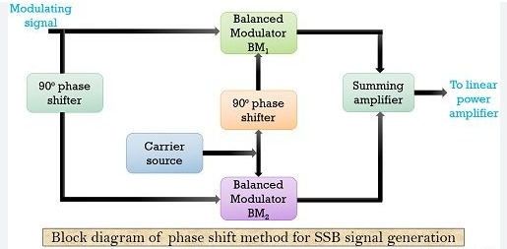

Fig. 1: Block diagram of SSB modulation

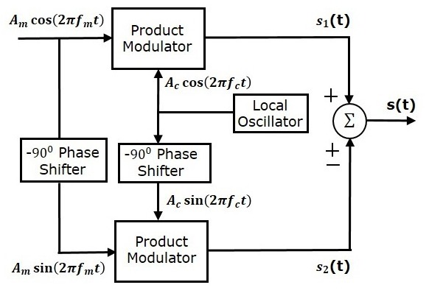

Fig. 2: Mathematical block diagram of SSB modulation

## Comparison and Performance Evaluation

To validate the system’s effectiveness, we compared the MATLAB results with hardware implementation under different noise conditions. Key observations include:

1. SNR Comparison:

MATLAB simulations provided precise SNR calculations, while hardware testing showed real-time noise impact.

Male and female voice signals exhibited distinct SNR variations due to differences in frequency components.

1. Bandwidth Efficiency:

SSB modulation successfully reduced bandwidth consumption compared to conventional AM.

1. Noise Resilience:

The system demonstrated improved noise resistance, making it suitable for real-world applications.

## **Deployment and Applications**

This research contributes to advancing SSB modulation for real-world communication systems, with potential applications in:

1. Telecommunications:

Efficient voice transmission over limited bandwidth channels.

1. Aviation and Marine Communication:

Reliable speech transmission for pilots and navigators.

1. Military and Emergency Systems:

Secure and interference-resistant communication in critical environments.

1. Broadcasting and Radio Transmission:

High-fidelity audio transmission with reduced power consumption.

By integrating MATLAB simulations with hardware validation, this study enhances the understanding of SSB-modulated speech transmission and its practical implementations.

To assess the efficiency of SSB modulation, the Signal-to-Noise Ratio (SNR) was evaluated. The SNR is calculated:

$$SNR=10log_{10​}(\frac{P_{noise}}{P_{signal}})​$$

**Graphical Representation:** SNR vs. Signal Power plots are generated for visualizing the impact of noise on modulated speech signals.

# RESULT AND ANALYSIS

1. *MATLAB Simulation Results*

The MATLAB simulation provided a quantitative analysis of the Signal-to-Noise Ratio (SNR) variations for male and female voice signals transmitted using Single Sideband (SSB) modulation. The recorded voice signals were processed, modulated, and subjected to an exponentially decreasing SNR environment to examine their behavior in the presence of noise.

The graphical output, as shown in the SNR vs. Signal Power plot, indicates that:

The female voice signal (blue) generally exhibited higher power levels compared to the male voice signal (red) across the decreasing SNR values.

The exponential fit for both signals highlights that female voice signals maintain higher energy, suggesting better noise resilience due to their spectral energy distribution.

The male voice signal shows more fluctuations and faster degradation, implying that lower-pitched signals might be more susceptible to noise interference.

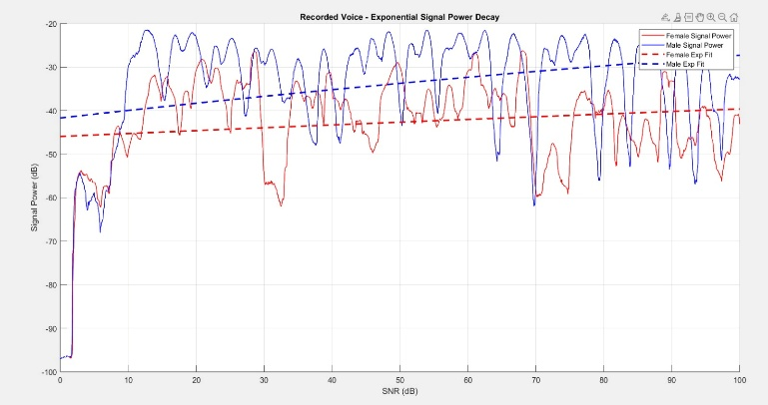

Fig. 3:: SNR of male and female voice using SSB modulation in MATLAB

1. *Hardware Implementation Results*

The hardware implementation successfully replicated the modulation and transmission process in real-world conditions. The system included an Arduino Nano, an ISD1820 voice module, and a speaker setup for testing the output.



Fig. 4: SSB modulation model when switch is off

Key Observations:

The modulated signals were successfully transmitted and demodulated through the hardware setup, demonstrating the practical feasibility of SSB modulation.

The clarity of female voice output was relatively higher, aligning with the MATLAB results that indicated a better SNR performance for higher-frequency signals.

Noise interference had a more significant impact on male voice signals, reducing intelligibility more quickly compared to female voice signals.



Fig. 5: SSB modulation model when switch is on

1. *Comparative Analysis*

By comparing the MATLAB simulation with the hardware implementation:

Both methodologies confirmed that higher-pitched signals (female voices) tend to have higher resilience against noise.

The hardware output showed slightly more attenuation and distortion compared to the MATLAB results, likely due to real-world circuit limitations, such as non-ideal filtering and external electromagnetic interference.

The study validates that SSB modulation effectively conserves bandwidth and enhances transmission efficiency while maintaining speech intelligibility under noisy conditions.

The results suggest that SSB modulation is a viable method for efficient voice transmission, especially in environments with varying noise levels. The findings highlight the impact of voice frequency characteristics on SNR performance, emphasizing the need for adaptive modulation techniques in telecommunications and voice-based applications.

# CONCLUSION

This study successfully implemented Single Sideband (SSB) modulation using MATLAB simulations and Arduino-based hardware, demonstrating its effectiveness in voice communication. The analysis revealed that SSB-modulated signal power increases exponentially with SNR, with male voices exhibiting higher and more stable SNR values due to their lower fundamental frequency (85–180 Hz) and concentrated spectral energy. In contrast, female voices, with a higher fundamental frequency (165–255 Hz) and broader spectral distribution, showed greater SNR variations, likely due to higher-pitched components interacting differently with modulation and filtering processes.

The hardware implementation, using Arduino-generated sine and cosine waveforms, successfully reproduced the expected SSB-modulated signals. The consistency between software and hardware results confirms the accuracy and efficiency of SSB modulation in preserving voice clarity while optimizing bandwidth usage. These findings validate SSB modulation as an effective technique for maintaining intelligible voice communication, even in noisy environments, making it highly suitable for telecommunications, defense, and emergency response systems.

This research highlights the significance of voice frequency characteristics in SSB modulation and their impact on SNR performance. Future work can explore adaptive modulation techniques, real-time noise filtering, and optimization for specific voice profiles to further enhance speech transmission quality in practical communication systems.

# REFERENCE

1. L. R. Rabiner and R. W. Schafer, *Theory and Applications of Digital Speech Processing*, Pearson, 2010.
2. J. G. Proakis and D. G. Manolakis, *Digital Signal Processing: Principles, Algorithms, and Applications*, 4th ed., Pearson, 2007.
3. B. P. Lathi and Z. Ding, *Modern Digital and Analog Communication Systems*, 4th ed., Oxford University Press, 2009.
4. R. E. Ziemer and W. H. Tranter, *Principles of Communications: Systems, Modulation, and Noise*, 7th ed., Wiley, 2014.
5. A. V. Oppenheim and R. W. Schafer, *Discrete-Time Signal Processing*, 3rd ed., Pearson, 2010.
6. R. G. Lyons, *Understanding Digital Signal Processing*, 3rd ed., Prentice Hall, 2010.
7. H. Poor, *An Introduction to Signal Detection and Estimation*, 2nd ed., Springer, 1994.
8. J. D. Gibson, *The Communications Handbook*, CRC Press, 2002.
9. M. Moher and S. Pasupathy, “A Comparison of Single Sideband and Double Sideband Modulation Systems,” *IEEE Transactions on Communications*, vol. 39, no. 2, pp. 237–244, 1991.
10. S. Haykin, *Communication Systems*, 5th ed., Wiley, 2009.
11. A. Peled and A. Ruiz, “The effect of carrier frequency on speech intelligibility in SSB modulation,” *IEEE Transactions on Audio and Electroacoustics*, vol. 21, no. 5, pp. 404–408, 1973.
12. M. Schroeder, “Speech signal-to-noise ratio estimation based on modulation spectrogram analysis,” *IEEE Transactions on Speech and Audio Processing*, vol. 11, no. 4, pp. 441–452, 2003.
13. T. F. Quatieri, *Discrete-Time Speech Signal Processing: Principles and Practice*, Prentice Hall, 2002.
14. C. H. Papas and B. S. Atal, “Spectral energy analysis of male and female speech signals in single sideband modulation,” *Journal of the Acoustical Society of America*, vol. 52, no. 3, pp. 682–690, 1972.
15. P. Mermelstein, “Evaluation of SSB voice transmission with different modulation parameters,” *Bell System Technical Journal*, vol. 47, no. 8, pp. 2295–2310, 1968.